[Email address]
November 2019
Multiple Long-Term Conditions
Exploring the priorities of people of working age: workshop report

Contents
Introduction 2
Acknowledgements 2
Workshop Design 2
Findings 3
Session 1: 4
What matters to you – but you don’t get asked? 4
What affects you a lot, that doesn’t ever get addressed? 4
Session 2: 7
What change would make the biggest difference for you? 7
Reflections 10
Appendices 12
Invitation 12
Background 13

Introduction
The National Institute for Health Research (NIHR) wished to understand how people living with multiple long-term conditions and their carers think about research in the field of multimorbidity, and what they would consider are the research priorities.
Multimorbidity, a term that is not liked by people, is a particular problem because often health and care services, guidelines and science are designed and based around single diseases. Patient care, science and research are organised around individual conditions and specialisms. To understand and support people living with more than one health condition there needs to be a more holistic approach that appreciates and responds to what it is like to live with a number of different health issues.
To develop this work, in 2019 NIHR commissioned three preliminary workshops to generate topics/priorities for future discussions with wider stakeholders. National Voices was asked to run one of these workshops for people of working age and their carers, making use of our long standing interest in person centred care, our expertise in capturing and explaining to others what matters most to people, and our network of non-profit member organisations across health and care.

Acknowledgements
National Voices would like to thank Versus Arthritis, Diabetes UK and Macmillan Cancer Support, and The Richmond Group of Charities, for their support in the planning and delivery of this workshop. Versus Arthritis kindly hosted the workshop in their accessible offices in central London and facilitation support was provided on the day by Versus Arthritis, Diabetes UK and NIHR.
The individuals who participated in the workshop travelled from across the country to bring their insight and experience, giving depth and value to the discussions that took place on the day. We are grateful for their generosity and commitment.

Workshop Design
This workshop was designed to bring together adults of working age living with multiple long-term conditions to discuss what matters most and to identify future research priorities to inform the work of the NIHR.
National Voices worked with The Richmond Group of Charities, which includes organisations working with the major long term conditions, and a targeted number of our member charities representing less common diseases, to recruit individuals from across the country to participate. Participants were offered an honorarium of £100 for their time and their travel expenses were reimbursed.
Following initial expressions of interest, individuals were asked a series of questions to ensure that they met the criteria to participate and as many experiences as possible were brought into the room. 20 individuals were initially selected, of whom 13 were able to attend on the day.
Prior to the day, participants were provided with a Discussion Guide which is included in the appendices of this report. The purpose of this guide was to provide some context to the workshop and to help participants understand what is already known from research.
On the day, the participants sat in three groups and, following an introduction and scene setting presentation, were given two questions to discuss as a group:
- What matters to you – but you don’t get asked?
- What affects you a lot, that doesn’t ever get addressed?
Following a comfort break, participants reconvened and were asked to sit in different groups before a second set of questions were posed:
- What change would make the biggest difference for you?
- What do we need to learn more about?
The purpose of these questions was to generate conversation without inadvertently directing participants to a particular area of research such as quality of life, service design, treatment or data.

Findings
Conversations that took place on the day were rich with insight and experience and participants felt that their voice was heard, welcoming the time to really get into good discussions around the questions that were posed. Clear themes emerged from the discussions and are described in the following sections.

Session 1:

What matters to you – but you don’t get asked?

What affects you a lot, that doesn’t ever get addressed?

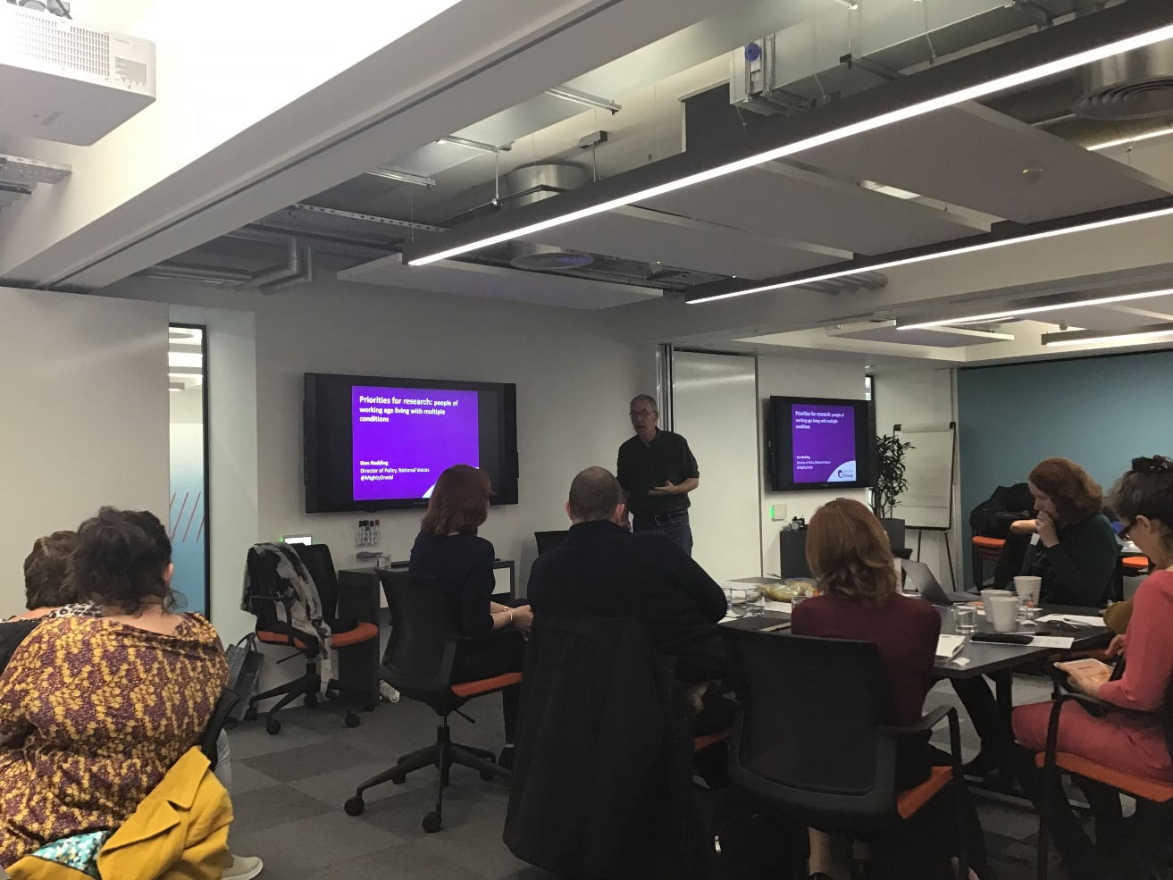

A] Mental and emotional well being
- General well-being – difficult to bring into the discussions in routine, often short GP or consultant appointments
- Mental health – people felt that professionals dealing with physical health were unwilling to address mental health needs, resulting in a lack of action, worsening symptoms and a consequent further impact on physical health
- Grief – people living with multiple long term conditions often experience their impact as a process of ‘loss’ – such as the loss of functions, independence, employment and participation in wider life – and feel this as a grieving process. This could be better recognised in their ongoing care

B] Uncoordinated care
- The ‘work’ of being a patient – a lot of people’s time and effort, and responsibility, is taken up by going back and forth to different clinics/people at different times in different places. This can be one of the impacts that prevents people continuing to work
- Administration -- the need to keep chasing appointments to make sure you are seen by the right person at the right time
- Inconsistencies in care that don’t get addressed, such as different advice on risk from different professionals, leading to the person being unsure what challenges they can take on
- Inefficiencies and repetition -- while seeing different specialists at different sites in different trusts, patient information is not shared and accessed, meaning the person has to become the carrier of the common ‘story’ of what is happening
C] Communication
- Mental health – people feel that when they raise the issue of the impact of their conditions on their mental health, clinicians find it difficult to respond
- Around diagnosis – some people experience a lack of information/communication beyond the basic clinical explanation and are therefore unprepared for the impacts on their emotional and social lives, leading to isolation and poor self-management
- Culture and attitude of medical establishment – wide variation in listening skills and communication ability between specialities, sometimes experienced as a variation in approach to care, for example in relation to discussing risk, lifestyle management and the feelings and experiences of the patient
D] Information and support
- There is variation in the level, type and quality of information given (e.g. patient information leaflets)
- Origins of disease. E.g. where there are clusters - are there environmental factors as to why people are diagnosed with certain diseases? (On one street 5 people diagnosed with Lupus)
- Burden of navigating the welfare system
- Employment – how to inform employers of diagnosis, how to tackle discrimination. People commonly experience employers being unable to understand the additional burden of having several conditions, and the need to make adaptations such as flexible working or time off for appointments
E] Self-management
- People experience changes in their own roles and those of other family members – for example, who cares for whom, and who takes on which family and domestic responsibilities. Likewise they experience changes in their own role in communities – for example, being less able to be involved in their favoured activities, or to take organising role in their communities of interest
- Identity - sense of achievement/self that is lost through ill health, particularly if the person loses their employment or career progression. People noted that this can be improved through volunteering/involvement with community or voluntary organisations
- People feel frustrated where their care focuses too much on symptom management/test results and not on supporting them to set goals and manage their day to day lives
Additional issues raised
- People of working age may feel stigma associated with ‘old people’s diseases’ like Alzheimer’s disease or other forms of cognitive impairment
- Fatigue – impacts on every aspect of life but is often not addressed or understood (‘I’m not just tired’)
- Unexplained symptoms – some people discussed their anxiety that their clinicians might want to focus on the main presenting condition and be unwilling to explore the possibility of further, undiagnosed illness

Session 2:

What change would make the biggest difference for you?
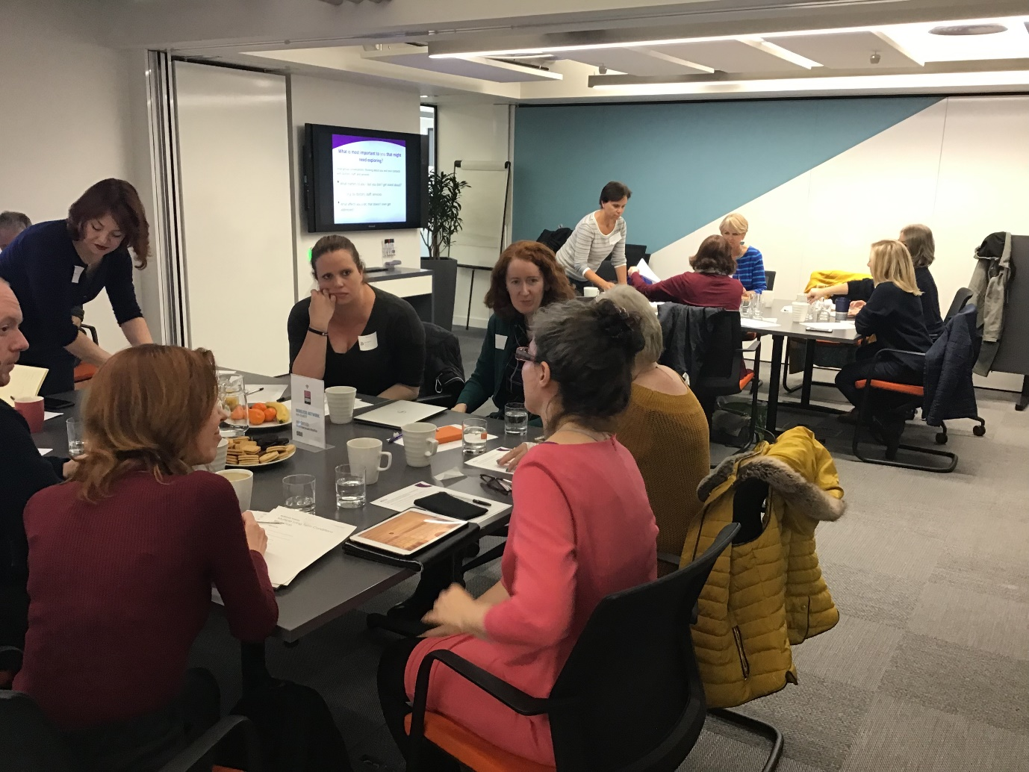

A] Mental and emotional well being
- Counselling being seen as a routine part of treatment offered from the point of diagnosis
- Early intervention – given coping strategies as a way of preventing further issues
- If clinicians asked ‘how are you feeling?’
- Better training for GP’s to recognise and be able to have conversations about mental health
- An open door to discuss me as an individual
B] Coordinated care
- Development of a person-centred plan around the choices people want to make and the things most important to them
- A specific person within a GP practice who has an umbrella overview to help navigate the administration of living with multiple long-term conditions
- Being able to see the same GP/consultant – continuity of care
- Sharing of good practice from one Trust to another – different Trusts have different ways of working
- Longer, more holistic GP appointments with the same GP

C] Shared patient information
- Access to patient records regardless of where treatment is based
- Test results/information not ‘getting lost’ on their way to the GP
- Integrated records system to bring all information together that is accessible by patients and clinicians
D] Communication
- Willingness of clinical staff to address sex and relationships
- Change in attitude around assumptions such as ‘you are too young to have x condition’
- If clinicians had a better understanding of the interplay between mental and physical health
E] Information and support
- Tailored information to enable informed decisions - people should be informed to make their own decisions about risks relating to their treatments and how they live their lives - no single pathway, treatment guideline or decision tool captures the life of someone living with three different conditions
- Signposting and direction after diagnosis, e.g. where to get advice on things like benefits. What can be done and who can help you? What can be given to you to give to your employers to help them understand your condition?
- Ongoing education i.e not just at point of diagnosis
- Age appropriate peer support/social groups to gain support from people who have had similar experiences
- If there was a central point for information that could be accessed by all as and when they need it
- Education and support that is specifically for people living with multiple long-term conditions – most services are disease specific

F] Self-management
- A system that facilitates education and understanding to support self-management
- Education to support self-management from point of diagnosis to help navigate support available and ‘the system’
- improved support to be less passive and to understand what services are appropriate
- Being trusted to have an emergency supply of medication for holidays etc

Additional points raised
- Earlier diagnosis, particularly for younger people and rarer conditions
- Improved access in rural areas to specialists
- Equity of access to treatments – people felt that because they are not ‘old’ their clinicians are slow to try different options
- More quality of life measures rather than just numbers
- Improved health literacy in schools and the public so people understand what it means to be living with MLTCs
- Flexible working arrangements which allow for the burden of living, and working, with MLTCs
- The understanding that I know my body – I am the expert
- Doctors trusting patients
- Families being more involved at point of diagnosis
- If someone asked, ‘what would help you the most right now?’ or ‘what matters to you? - agenda setting and shared decision making
- Patients are all different – even those with the same condition. Not everyone is the same and patients should be treated as individuals
- It should not be a fight to get access to treatments/services/benefits
- Development of multiple long-term conditions – are they independent of each other or are some related to others? People want to understand the science underlying their conditions
- Efficacy of treatments for people who have more than one condition – current ways of testing doesn’t include people with a number of conditions
- Choice of treatment – not tailored to patient often feels like cheapest option is given first
- International collaboration to treat and support people with multiple long-term conditions

Reflections
None of the above findings is surprising. Previous investigations into ‘chronic care’, and work with people with long term conditions, have established that people need care and support that helps them live their best lives, which is based around approaches such as care planning, care coordination, support for self management and shared decision making.
What became apparent as people in the workshop talked and listened to each other is that the ‘medical model’ which focusses largely on biomarkers (treatment thresholds, blood sugar levels, testing regimes) tends to fail people who live with more than one health problem.
Where people are managing more than one health problem at a time, care that is disjointed, doesn’t identify the ambitions and concerns of the individual and doesn’t build effective support for people to be able to maintain wellbeing may help with aspects of disease management, but also adds burdens to people’s lives and doesn’t add enough value. This is wasteful and ineffective care.
Where these people are of working age, the significant work of attending many appointments, chasing progress, administering one’s own care and linking up fragmented information in itself creates additional barriers to being able to continue in work or pursue other meaningful activities.
At the same time people have to make sense of new domains of life such as dealing with an opaque welfare benefits system, or finding out what additional services and support might be appropriate and helpful.
Where people are trying to remain in work, they find themselves up against a lack of understanding by employers with regard to the double burdens of both the direct impact of their health conditions, and the additional burdens described above. People in the workshop wanted both formal (school based) and public education, and resources for employers, to help overcome these barriers.
People of working age discussed their anxiety that they may not be getting equal or appropriate treatment compared to those who are older and therefore are ‘expected’ to contract diseases. Some felt that clinicians were reluctant to proceed quickly through the options for tests and treatments, or to give additional diagnoses beyond the initial condition; and that professionals could potentially carry a similar bias to the general population – that ‘it can’t be xxx, because you’re too young to be having that’.
The experience of having several diagnoses and the impact of several conditions is felt as a grieving process – for example, in relation to the loss of identity, functions, access to work and career, and previous roles in the family and community. Workshop participants repeatedly discussed their need for the services they encounter to acknowledge, recognise and respond to the emotional and social impacts of their conditions.
The notes from Session 2 include a number of general and specific suggestions for changes that might help people of working age with multiple conditions. We hope that these can help the NIHR to develop further research questions.
We would expect that some themes will be found to be common across age groups: the desire to connect mental and physical health; to experience holistic approaches that combine clinical support and support for self-management; and to be recognised as an equal partner and expert on one’s own health and needs.
National Voices stands ready to help develop this thinking further and to ensure that whatever next steps are decided upon, we do not lose sight of the assets, insights and energy people living with multiple health conditions can bring to this challenge.

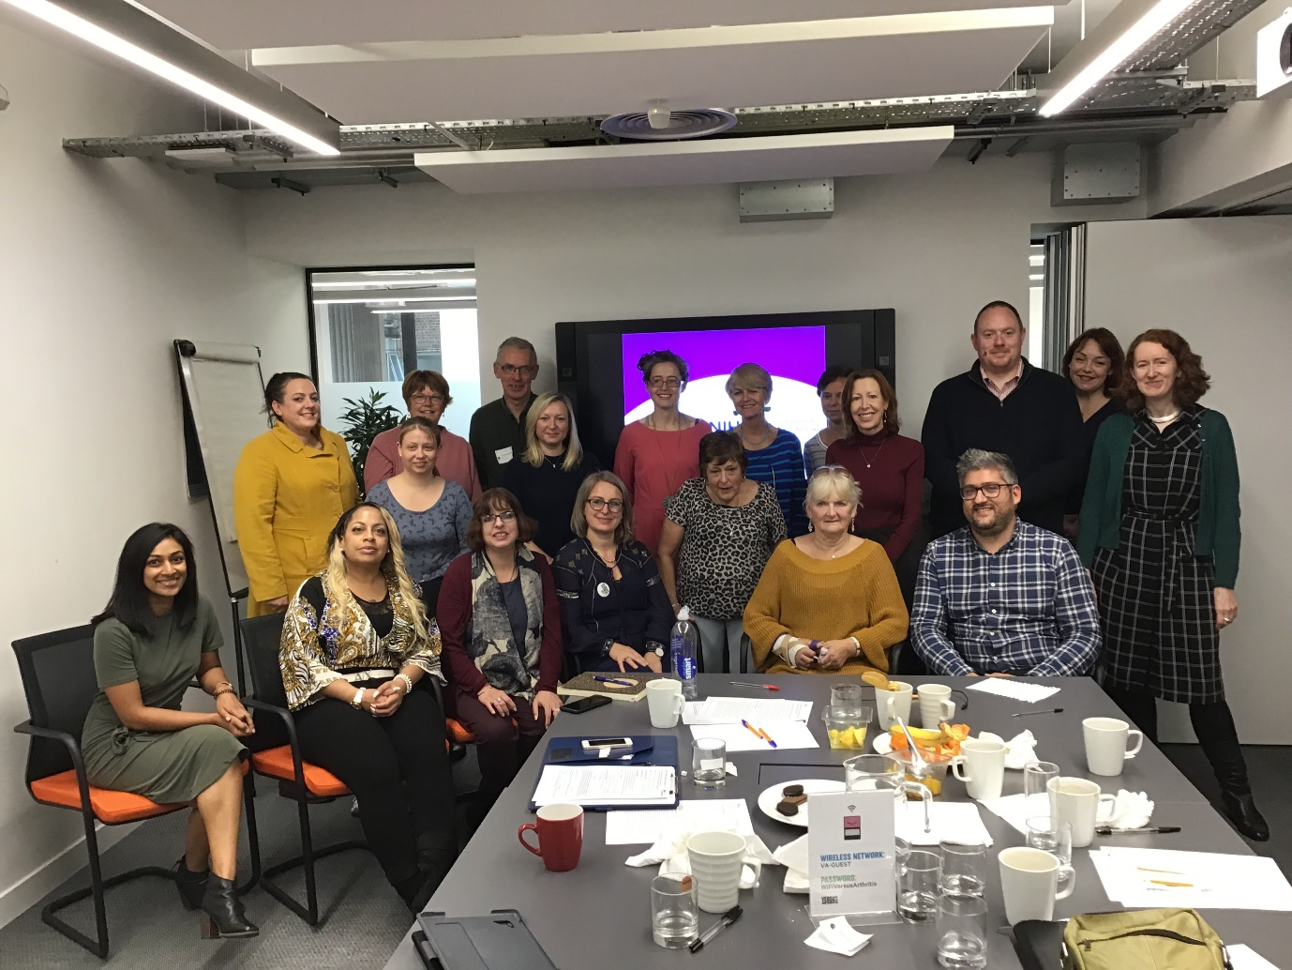

Project leader and report author: Kate James
Facilitator and report editor: Don Redding
Communications and photos: Sam Batey

Appendices

Multiple Long-Term Conditions Workshop

Invitation

Are you, or someone you care for, living with multiple long-term conditions?
Are you tired of having to tell the same story to different people in different settings over and over again?
Could you tell national researchers and service leaders the key things that would improve your care and support and your experience of services?
National Voices are working with The National Institute of Health Research (NIHR) to find out what matters most to working age people who are living with multiple long term conditions and we are holding a workshop to capture a range of perspectives from patients, service users and carers. Sharing some of your experiences in this workshop will help to shape future research priorities across health and care.
You will be given an honorarium of £100.00 for your time and we will reimburse your travel expenses. Refreshments will be available throughout the afternoon.

Workshop details
When - Monday 7th October 2019, 13:00 – 16:00
Where – VersusArthritis Saffron House 6 10 Kirby Street London EC1N 8TS
How to get involved – Email info@nationalvoices.org.uk by 22nd September with the subject ‘LTC Workshop’ telling us a bit about you and your health conditions. We will then be in touch with some further questions to make sure we have a range of voices in the room.

Multiple Long-Term Conditions Workshop

Background

In April 2018, The Academy of Medical Sciences (AMS) published a report on Multimorbidity. Multimorbidity is the co-existence of two or more chronic conditions in an individual; this can include both mental and physical health conditions. Following the publication of this report and an implementation workshop in June 2018, the AMS, Medical Research Council (MRC), National Institute for Health Research (NIHR) and Wellcome have come together to: encourage and develop work to overcome the structural barriers facing multimorbidity research; support the research needed to better understand the trends, burden, causes, prevention, and management of multimorbidity.
The NIHR Strategy Board has requested a strand of work that seeks to identify and research what matters to people with multimorbidities and their carers. Multimorbidity is a particular problem because much of the way health and care services, guidelines and science are designed are based around single diseases. Therefore, patient care and science and research are often built around individual conditions and specialisms; to understand and treat multimorbidity we need a holistic approach – we want to put patients and carers at the heart of this approach.
The NIHR Strategy Board has developed an innovative process to co-produce a call for research on what matters to patients and carers, which involves a series of discussions and workshops resulting in a sandpit to bring together patients, carers, researchers and decision-makers in the health and social care system. They hope this work will:
- raise awareness of lived experience of multimorbidity as an important issue
- create a community of organisations and public contributors who are engaged in multimorbidity research development and who are working collaboratively
- aim for an NIHR and/or cross funder call to be developed which can inspire by a range of high-quality applications of benefit to patients and carers
- and that the output acts as a trigger for other activity across the health research system which takes the patient perspective
The NIHR have commissioned three preliminary workshops, one of which is with working age people with multiple long-term conditions and their carers. There will also be a session with young people and carers of children with multiple disabilities; and one with older people to cover the full life-course.
Later discussions following these workshops will consider and agree priority areas for future research and begin discussions as to how these might be translated into call questions (e.g. framing, language, aims, what success would look like etc). The final format is still in development.

PEOPLE WITH MULTIPLE HEALTH CONDITIONS: Discussion Guide
Why are we talking about ‘multiple health conditions’?
Around one quarter of adults in England have a ‘long term condition’ (ltc): a disease that is unlikely to be cured, and so has to managed as part of the person’s life.
Many NHS services, and most medical research, are organised around single conditions such as diabetes, heart disease or lung disease.
But as the NHS gets better information on the population, we are discovering that people who have one ltc will usually have others at the same time.
For example, doctors in Somerset looked at people with Type 2 diabetes and found that only 14% of them had it as a single condition. The majority of people had diabetes and two or more other conditions.
The medical term for this is ‘multimorbidity’, but we know that people do not like this label (‘It sounds like a lot of ways to die’). So we are talking about living with multiple conditions.
This information changes how we think about the way services might need to be organised.
And if we want to rethink services and treatment, we might need new kinds of research that look at the needs and experiences of people with ‘multiple conditions’, and the best ways to treat, care for and support them.
What do we know so far?
Here are some key findings from recent research into multiple conditions:
- Around one quarter of people in England live with two or more conditions, and the numbers are predicted to keep growing over the next five years
- This is more likely when you are older: two thirds of people over 65 have two or more conditions
- But it is not all about age: ‘multimorbidity’ goes across the age ranges. Researchers describe it now as ‘common’, or ‘the norm’. It includes many people of working age
- There is a strong link between deprivation and multiple health conditions; and between loneliness and multiple conditions
- If you are poor you are almost twice as likely to develop multiple conditions
- Poor people get multiple conditions 10-15 years earlier in life than better off people, and are more likely to have both mental and physical health conditions
- One study of an inner London population in two deprived boroughs showed that it is common for people to be diagnosed first with a mental health need (such as stress, anxiety or depression), often in their late 20s or early 30s, and for physical conditions to follow
- People with multiple conditions are likely to have many medicines to take, frequent visits to their GP, many planned hospital appointments during the year, more visits to urgent and emergency care, and more unplanned admissions to hospital
- Having to follow lots of different courses of treatment for different conditions adds to the ‘work’ of being a patient and is sometimes called ‘the burden of treatment’

What is the NHS recommended to do based on existing research?
The NHS is guided in what it should do by the National Institute for Health and Care Excellence (NICE). NICE looks at available evidence and decides what kinds of treatments and what kind of service design the NHS should use.
Most NICE guidelines are about specific single conditions. But in 2016 it published its first guidance on assessing and managing ‘multimorbidity’: NG56. This guidance:
- Warns all clinicians to be aware that the people they see for one condition may well have others
- Says NHS services should have ways to identify patients with multiple conditions
- Says the following people may benefit from a different approach to their care: people struggling to manage; using many services; having both mental and physical conditions; becoming frail or having falls; frequently going to emergency care; and/or taking a lot of regular medications
- Recommends that the ‘different approach’ should be what NICE calls ‘tailored’ care – see below
Tailored or personalised care
NICE describes tailored care as focusing on the quality of life of the person, including: how their conditions and treatments interact with each other; when to depart from treatment plans that are for single conditions; how to reduce the burden of treatment, including by reviewing and reducing medicine usage; coordinating care to reduce unnecessary appointments and delays; and in all of this, being guided by the priorities, values and life goals of the person. Those goals may include things like remaining independent, or staying in work.
Much of this would be recognised by others as ‘person centred’ or ‘personalised’ care.
In the NHS Long Term Plan, NHS England sets out a ‘comprehensive model for personalised care’ to be implemented over the next five to ten years. This includes helping people with long term conditions to define their personal care plan; to learn how to manage their lives and conditions as well as possible; to take part in decisions about treatments; and to be referred to other sources of support outside the NHS, such as community groups and organisations, financial and benefits advice, and so on.
Key question for the NIHR workshop 7th October 2019
This brief summary helps participants understand what is already known from research, and what that evidence has led to in terms of how care might be reorganised in the future, for people living with multiple conditions.
The key question for participants now is: what should be the next priorities for research, based on your experience, views and priorities as people of working age, living with multiple conditions?

https://www.nice.org.uk/guidance/ng56

